Name(s)_______________________________________________ Period ______ Date ___________________

|  |  |  |
| --- | --- | --- |
|  | **Activity Guide - Variables Make** |  |

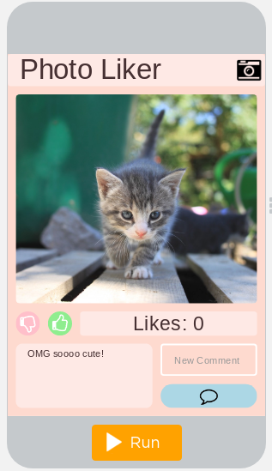

"likeCounterOutput"

"newCommentInput"

"commentButton"

"downButton"

"upButton"

"allCommentsOutput"

**Your Goal:** Write the code to make the Photo Liker App. You've already been given every screen element and have comments that will help you design your program.

**Step 1 - Try using this app**

* Try all of the buttons and add a comment to the picture
* Discuss with a Partner
  + What does this app do?
  + What are the inputs?
  + What are the outputs?
  + What's one piece of information that might be stored in a variable?

**Step 2 - Plan**

Fill in the information in the table below for each event handler you'll need to create

|  |  |
| --- | --- |
| **Element ID** | **Description of What the Event Handler will Do** |
|  |  |
|  |  |
|  |  |

Fill in the table below for each variable you'll need to create.

|  |  |
| --- | --- |
| **Variable Name** | **What the Variable Stores** |
|  |  |
|  |  |

**Step 3 - Write Your Code**

* Write the code for the app, using your plan above and the comments provided in Code Studio to help
* Step You Can Follow
  + Create all the variables from your table above.
  + Give your variables a starting value using the assignment operator (=)
  + Create blank event handlers (onEvent) for each screen element in your table above
  + Write the code to make the "upButton" work and test it out. If it's working correctly, the "Likes" count should go up by one every time you click it
  + Write code to make the "downButton" work and test it.
  + Write code to make the "commentButton" work
  + Use your debugging skills to identify unexpected behavior and fix your program
  + Comment your code as you go, explaining what each event handler does
  + Check the Help & Tips tab for ideas about Programming Patterns you can use
* Extension Ideas
  + Set the text in "new_comment" to blank after the comment has been added
  + Add sounds to each button

**Step 4 - Submit**

Before your submit check the rubric below to make sure your program

|  |  |  |  |  |
| --- | --- | --- | --- | --- |
| **Category** | **Extensive Evidence** | **Convincing Evidence** | **Limited Evidence** | **No Evidence** |
| Code: Event Handlers Created | onEvents are defined for all the required buttons. | onEvents are defined for most of the required buttons. | onEvents are defined for some of the buttons. | onEvents are not designed for any buttons. |
| Code: Variables | Variables are defined to store the amount of likes and the comments. Variables are named in a clear and understandable way. | Variables are defined to store the amount of likes and the comments | One variable is present that stores either the amount of likes or the comments | There are no variables which store the necessary information for the app to work correctly. |
| Code: Event Handlers Written | All necessary variables are updated inside of the onEvents. | Most necessary variables are updated inside of the onEvents. | Some of the necessary variables are updated inside of the onEvents. | None of the necessary variables are updated inside of the onEvents. |
| Code: Output Information | The screen correctly displays the amount of likes and the total comments. Sound plays when different buttons are clicked. | The screen correctly displays the amount of likes and the total comments. | The screen correctly displays either the amount of likes or the some amount of comments. | The screen does not display the amount of likes or the comments. |
| Code runs without errors. | No errors are present in the code. | At most one error is present in the code. | Some errors are present in the code. | Many errors are present in the code. |
| Coding Comments | Comments are used to correctly explain the purpose and function of all onEvents. | Comments are used to correctly explain the purpose and function of most onEvents. | Comments are used to explain the purpose and function of some onEvents. | Comments are not present |